GRADE 7 ACCELERATED · UNIT 2 · LESSON 1  Square Values  Additional Practice 7A.02.01 | Name_________________________  Date__________________________  Period________________________

1. Complete the table. Each area is the side length multiplied by itself.
Side s | 6 | 7 | 8 | 9 | 10 | 11 | 12 | 13 | 14 | 15
Area s²

2. Select ALL of the numbers below that are perfect squares.
☐ | 4 | ☐ | 12
☐ | 25 | ☐ | 32
☐ | 50 | ☐ | 81
☐ | 90 | ☐ | 121
☐ | 150 | ☐ | 169

For questions 3 through 5, find the area of a square with the side length given.
3. Side length 15 units

4. Side length 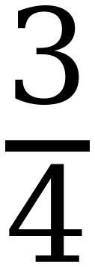 meters

5. Side length 1.2 units

For questions 6 through 8, find the length of one side of a square with the area given.
6. Area 169 square inches

7. Area 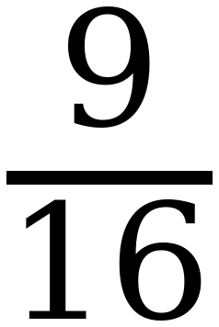 square meters

8. Area 0.64 square units

Questions 9 and 10 use the equation y = x².
9. Complete the table of values. Then plot the points on the grid.
x | Substitute into y = x² | Coordinates (x, y)
−3
−2
−1
0
1
2
3

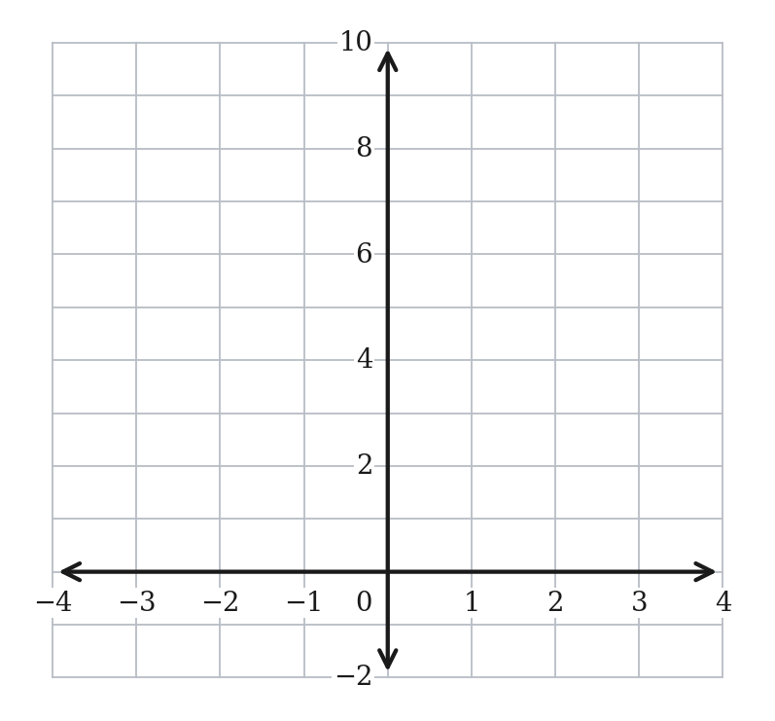
10. A classmate says the graph of y = x² is always above the x-axis. Is the classmate right? Explain.

11. Can a square have an area of 20 square units? If it can, name the two whole numbers its side length falls between. Explain how you know.

